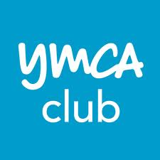
H²O Building Services
8a Rishworth Street
Wakefield, West Yorks
WF1 3BY
Tel: 01924 387873
Fax: 01924 565487
www.h2obuildingservices.co.uk

CLIENT: YMCA Club
LOCATION: 112 Great Russell Street, WC1B 3NP
CURRENT SUPPLIER: Thames Water
DESC. OF SUPPLY: metered 1 x 100mm 1 x 25mm meter
ACC. NO: 61446 52153

Average annual water consumption: 76,650
Average annual cost: £ 140,000.
Facilities on site: Hotel and leisure club with pool and spa.

Our desktop water audit reveals potential saving of £ 30,000pa.

In order to put together a firm specification and cost of the work to achieve the savings a site survey is required. Upon completion a written report will be generated detailing specific areas of savings, action required to achieve those savings, specification, cost and payback (most projects 6 months or less).

Recommendations:

To carry out a site survey, submit a written report for action including specification of works to achieve savings.
Survey and report fee £ 850 + VAT.

Potential Annual Savings:

Estimated at £ 30,000.

