Car Garage - Durham

Water Leak Detection Site Survey Report
22nd June 2016
We attended the Car Garage Durham site on Monday 21st June to carry out water leak detection after receiving a high consumption water invoice.
We arrived at site and met with the Branch Manager. Our usual practise is to sign in upon arrival to site but unfortunately no signing in book was available.
We took two meter readings whilst on site. The meter (91P724733) is located in a grass verge on public property behind the vehicle washing area & the internal stop tap is located in the plant room at the rear of the main sales and service building.
At 9am the meter read 31026m³ and at 10.30am the meter read 31028m³. During this time there was no usage on site but the site had still used 2m³ of water in 1.5 hours meaning the site had an unaccounted water loss of approx. 1.33m³ per hour.
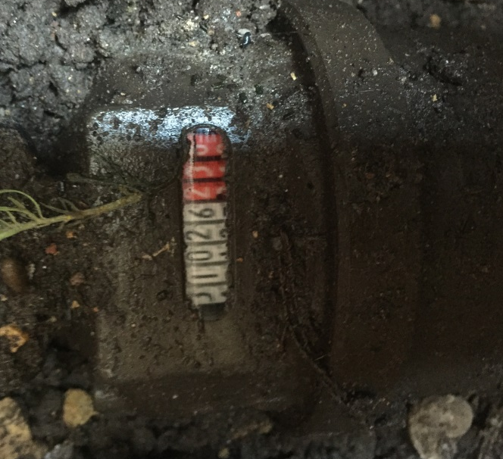

Meter Reading 31026 taken at 9am
Meter Reading 31028 taken at 10.30am

An unaccounted water loss of 1.33m³ per hour equates to an unaccounted consumption of approximately 31.92m³ per day which carries cost of approximately £3.02 per hour, £72.48 per day and over the course of one year, an unaccounted cost of £26,455.20.
From the plant room there is a 32mm MDPE pipe proceeding to the vehicle wash. We isolated this branch first and found the pipe to be sound. This confirmed that the leak was internal.
We proceeded to then carry out leak detection in the staff canteen, service workshop toilets and service workshop, ladies toilets and men’s toilets in the sales areas.

We noted that the urinal in the men’s toilets sales area appeared to be flushing constantly. We removed the access panel and found the solenoid valve to be sat in the open position.
We then carried out a check on the unit by depressing the small black button on the PIR sensor and it indicated that there is a problem with the battery/power pack.

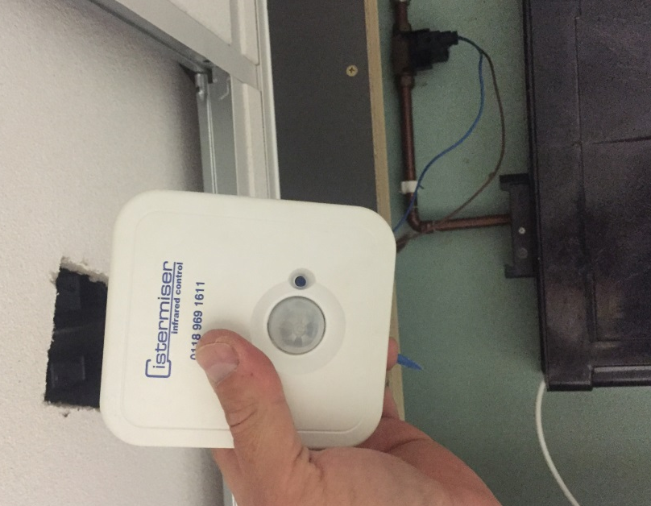
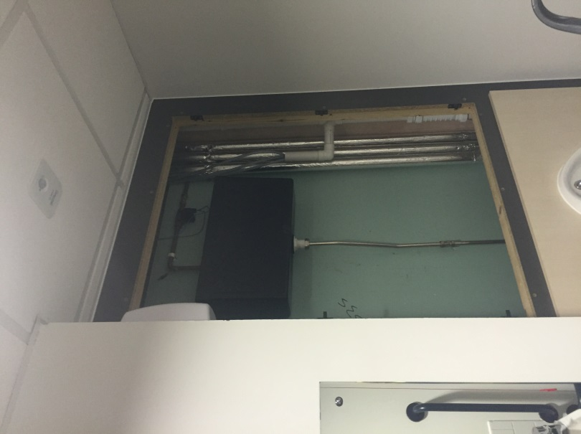

We checked the PIR sensor and it indicated there is a problem with the battery/power pack
We removed the panel and found the solenoid valve to be sat in the open position

All other facilities we examined appeared to be sound with no running overflows or pressure relief valves passing.
We isolated the valve to the urinal and the external meter stopped registering water consumption indicating that by isolating the urinal, we had eradicated the high consumption issue.
Our engineer advised the Branch manager and offered to turn down the flow to the urinal system to save water until the issue is fully resolved. He accepted our recommendation and we turned down the valve which will save water whilst a new battery pack is installed on the urinal control/new urinal control is installed.
We would recommend a direct replacement for the urinal control. The urinal control currently in place has failed with the solenoid valve being left in the open position which means the urinal is constantly running and you subsequently incur a high invoice.
Our urinal control, if it fails or requires a new battery pack, keeps the valve closed so water cannot run straight through into the urinal and cause a high water bill.
Recommendations
Direct Replacement of cisternmiser
Cost to Supply Only: £XXX + VAT + Carriage
Annual Saving: £26,455.20

