Car Sales Maidstone

Accident & Repair Centre

Leak Repair Report
28th July 2016
We attended the Car Sales Maidstone site on Monday 25th & Tuesday 26th July to carry out our repair recommendations to excavate at the water meter and thrust bore 15m of new 25mm MDPE pipe from the water meter to the section of pipework that was cut out to carry out the squeeze off during our leak detection visit thus eradicating the leakage on the supply.
We carried out the necessary excavations to enable us to mole the new supply in. We began to mole the new 25mm MDPE supply pipe but due to underground obstruction from rock and concrete, the mole could not break through and subsequently had to be dug back out on two occasions thus slowing our progress down.
However, we persisted and eventually the mole broke through and we were able to mole the remainder of the 25mm pipework to allow us to complete the relay.
We cut out the existing leaking pipe, replaced with new MDPE pipe and connected up at the water meter and point of entry.
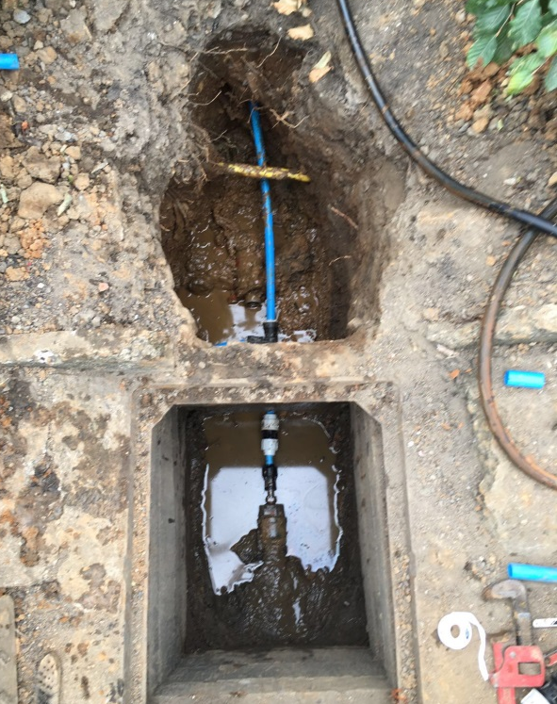
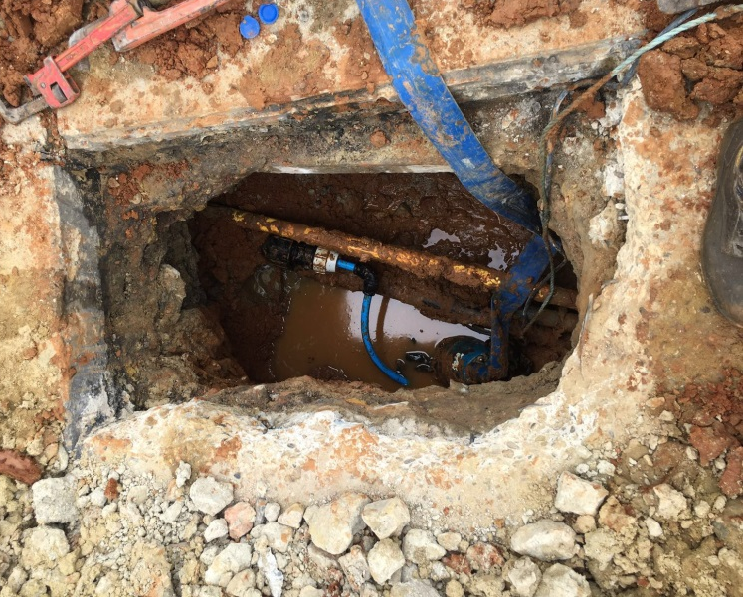

Picture 2 – A further moling further up into the supply relay
Picture 1 – The first moling from the water meter to relay the new 25mm water supply

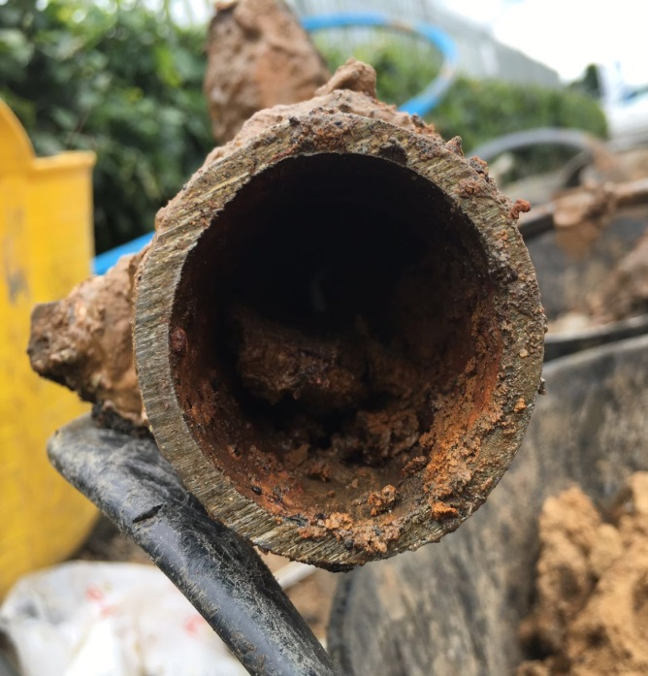
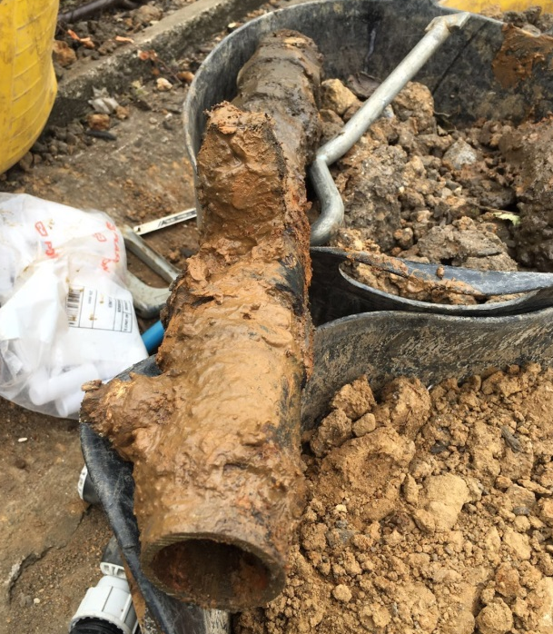
As the old supply was found to be heavily rusted when we cut the leaking section out, there was potential that some of this rust could have made its way through the water supply into the property.

Picture 4 – The heavily rusted interior of the galvanised iron supply
Picture 3 - The leaking section of galvanised iron pipe that was cut out
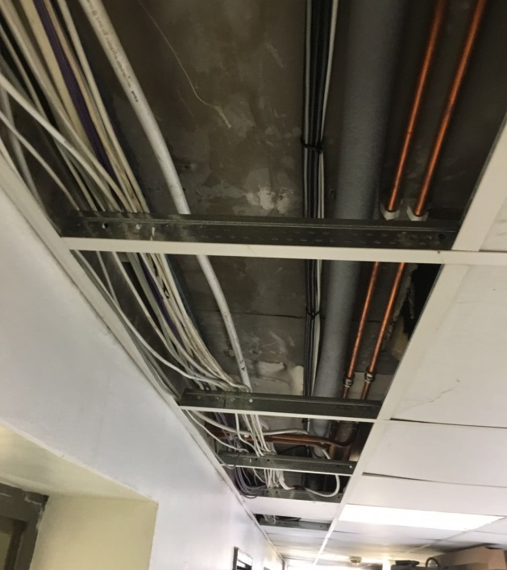
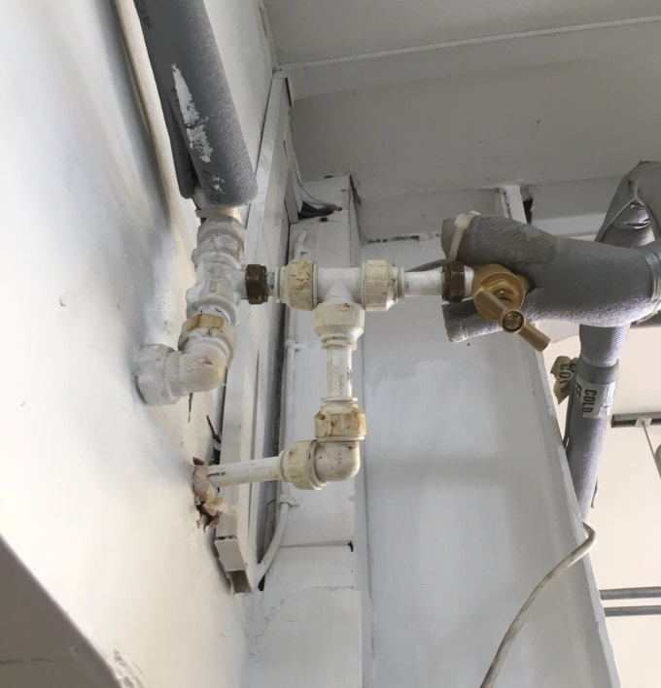
Therefore after connecting the new 25mm MDPE pipe on the external supply, we isolated the water to certain areas of the site & made the decision to run 10m of H2O white water pipe internally and connected up at the supply to the outside tap which subsequently bypassed all the rust blockages found on the old supply.
Picture 5 & 6 – We ran 10m of H2O water pipe internally through the building and connected up at the supply to the outdoor tap, bypassing the rust blockages

We backfilled all excavations and reinstated in concrete, leaving site clean & tidy.
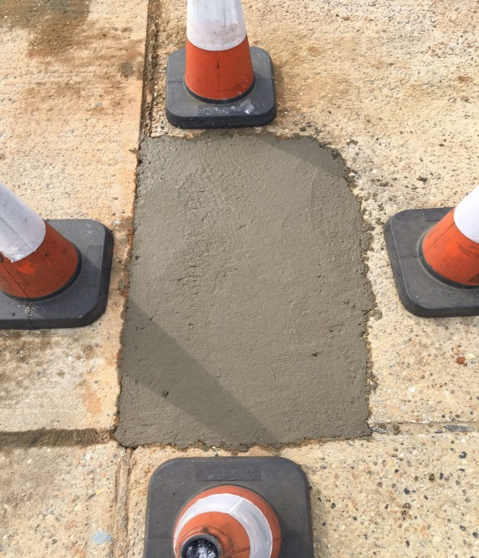
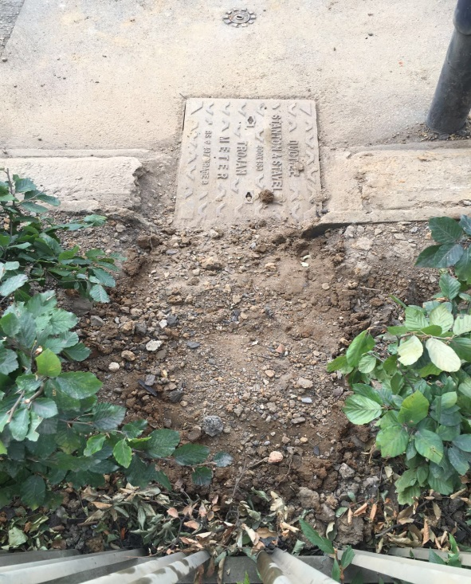

Annual Saving
£3,114.18
[Type a quote from the document or the summary of an interesting point. You can position the text box anywhere in the document. Use the Drawing Tools tab to change the formatting of the pull quote text box.]

